Group 17 Project Report (Spring 2019)

**Project Description:** Our web application allows Case students to buy and sell their special meal swipes. Special meal swipes are valued at around $13 per swipe and allow students to buy meals outside of dining halls such as Tink, Jolly Scholar, The Den, and Tomlinson. Users can post the special swipes they would like to sell (creates swipe data in the swipes table) on the *Sell* page. Also after created a listing, sellers can delete listings that they created (deleting swipe data from the database). On the *Buy* page, a list of all available meal swipes for sale are listed (aggregate and display the total number of meal swipes available as well as average price per swipe and price per swipe in each listing). Students can then go in and buy the meal swipes listed (updates a status value on a swipe), or view the history of their purchases.

Our project uses MySQL, Python, and HTML/CSS for the database and web application. Our web page displays the total number of meal swipes available to buy and their average price on the *Buy* page, buttons corresponding to buying meal swipes on the *Buy* page, a button to view your purchase history, a way to sell/create a listing or a meal swipe on the *Sell* page, and buttons to remove listings that a user has created before they are bought on the *Sell* page. It also features a login page for the *Sell* page as well as assigning a guest user ID to a buyer to keep track of who is buying/selling the swipes.

**System Design**

Overview:

* Our project is a CWRU meal swipe store called Triple S (Special Swipe Store).
* Tech Stack: Web app using HTML/CSS with Python/Flask server and MySQL database backend
* Scope: the site (1) allows customers to post the special swipes they would like to sell (creates swipe data in the swipes table) (2) lists all available meal swipes for sale (aggregate and display the total number of meal swipes available as well as the average price) (3) allows customers to buy the meal swipes listed (updates number of meal swipes available and updates the status of a swipe) (4) allows sellers to remove their listings if the swipe is not already bought (deleting a swipe from a database) and (5) allow users to view the swipes they have purchased.
* Sellers login to sell their swipes by providing a CWRU network ID and a name. They create a swipe listing with a total price and quantity of swipes they are trying to sell. Buyers login with a CWRU network ID and also get a predetermined ID in order to buy. Some customer and swipe information will be pre-populated, but it can easily be populated by creating swipes to sell.

**Process Flowchart:**

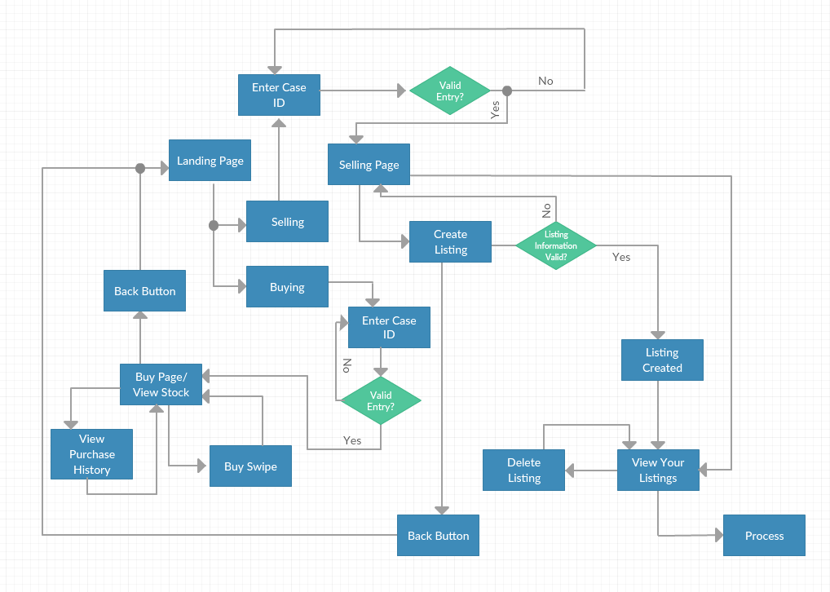

**Data Model (E-R Diagram):**

Entities: user, swipes, guest_user

Relationships: Sell, Buy

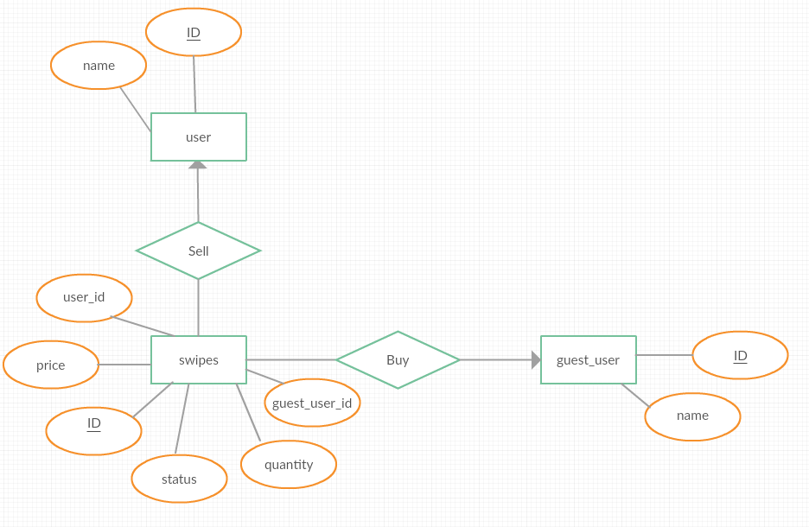

**Relational Schemas:**

Entities:

user(**ID**, name)

PK: ID is a unique user id for each seller

swipes(**ID**, price, quantity, user_id, guest_user_id, status)

PK: id is a unique swipe id for each swipe being sold

FK: user_id references user.ID

FK: gues_user_id references guest_user.ID

guest_user(**ID**, name)

PK: ID is a unique guest user id for each buyer

**Contributions:**

**Planning:** All of the group members worked out the timeline and hours of work estimations together. In regard to the system design, Drew Heald lead the work on the E-R diagram, Madison Lucas and Gloria Tie worked on the relational schemas from said diagram, and Ben Baierl lead the work on the Process Flowchart. All members contributed to the project description and overview.

**Backend:** Drew Heald and Ben Baierl setup the MySQL database with all of the required tables, keys, and attributes. This entailed created the tables originally, but also updating them as the team ran into problems that required change to some aspects of the project/database. Work was also done to help write the queries that were used in the python portion of the code.

**Frontend:** Gloria Tie and Madison Lucas lead the way on the frontend work. Madison, with slight help from Ben Baierl, focussed on the *Buy* page by creating an HTML document to display the information as well as working to integrate it with the python code. The main challenges of this page included keeping track of unique buyer IDs and displaying the list of swipes available for purchase. Gloria Tie focussed on the *Sell* page, which included a login page for users. The main challenge here was input handling and error checking, as well as displaying the appropriate swipes associated with that user. Drew Heald, Madison Lucas, and Gloria Tie worked on making the site more presentable using CSS.

**Report:** Ben Baierl lead the way on this report with the help of all group members: Madison Lucas, Gloria Tie, and Drew Heald. This entailed updating the E-R Diagram, System Flowchart, project description and overview, and the relational schemas to portray the changes made to the project along the way.

**\*\*** Everyone contributed fairly and equally to all parts of the project. Mentioned above are mostly the individuals that lead each part. **\*\***

**Reflection:**

This project has taught each group member various things from coding with different languages to working well in a group dynamic. Below are each individual’s short reflection on what the project has taught them.

**Ben Baierl:** Before this project I had not coded in Python at all and had only done a small amount of html coding. This project taught me the intricacies of python and html as well as putting the MySQL work we had done in class to practical use. It reaffirmed my knowledge of MySQL and databases as we had to create/update tables and their attributes from a blank slate. In regards to Python, I learned a lot of the syntax of Python code as well as how to connect an html template to said Python code. I also learned more about CSS and GitHub. Another thing that I learned is that projects will grow and evolve the farther you get into them. Sometimes what you originally have in mind does not come to fruition, but rather it adapts and may have taken a different path than you thought to finality. Lastly, I learned how important good team work is as this project seemed relatively painless due to my team’s amazing communication/participation.

**Madison Lucas:** I have never created a web-based application before doing this project. I am glad I took on a primarily front-end development role, as this project forced me to learn the basics of Git, Python, CSS, and HTML. I had no experience outside of basic MySQL queries and object-oriented programming. I can now write HTML pages and sync them up with databases via Python, as well as abstract some of the details to CSS. I am grateful for teammates who were hard-working and patient. They were always willing to listen to others and explain their ideas. This project was fun to complete and I learned very useful skills for web-development.

**Gloria Tie:** I had some experience with Python and using Flask to host a webpage, however before this project, I never used a database to write and store data from the web application. I enjoyed learning how to communicate between the HTML page and our Python script and using MySQL queries to display data onto our webpage. Since we didn’t have strict roles for this project, I was also able to be in frontend but also learn how our backend worked and was set up. The team had clear deliverables that each member knew they were responsible for, and I believe that the communication between all of us was the reason we were able to work cohesively. Working on this project has taught me how to communicate effectively with my other team members so everyone is on the same page and understands (at a high level) how each part of our program works.

**Drew Heald:** I have had a bit of exposure to Python, HTML, and CSS before this project, but working on this has definitely made me more comfortable with using them. I have also become far more adept at using MySQL, and feel confident navigating the Oracle reference pages. This was also my first time using Git, and I am now confident that learning to use Git in a more professional setting will be a simple task. I got exposure to several different tools and techniques that I haven’t used before while working on this project, and feel more comfortable going into positions that would require me to learn on the job. I enjoyed working with this group, as we had good communication, and met regularly to work.